December 5, 2017

The Honorable Michael Crapo

Chairman

The Honorable Sherrod Brown

Ranking Member

U.S. Senate Committee on Banking, Housing, and Urban Affairs

534 Dirksen Senate Office Building

Washington, D.C. 20510

Dear Chairman Crapo and Ranking Member Brown,

I am writing on behalf of SunTrust to express support for S.2155, the Economic Growth, Regulatory Relief, and Consumer Protection Act of 2017. This legislation contains a number of thoughtful provisions that enhance consumer protection and provide regulatory relief while ensuring the safe and sound operation of the financial system. Passage of this bill will support growth and prosperity and protect the financial interests of the millions of Americans that rely on financial institutions for products and services.

The bipartisan group of senators that worked to produce S.2155 should be commended for their efforts to provide tailored regulation for the traditional, deposit funded banking organizations that serve thousands of communities and millions of families across the country. We hope that it is readily passed by the Committee and the full Senate.

Sincerely,

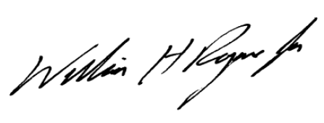

William H. Rogers, Jr.

Chairman and Chief Executive Officer

SunTrust Banks, Inc.

cc: Members of the Senate Banking Committee